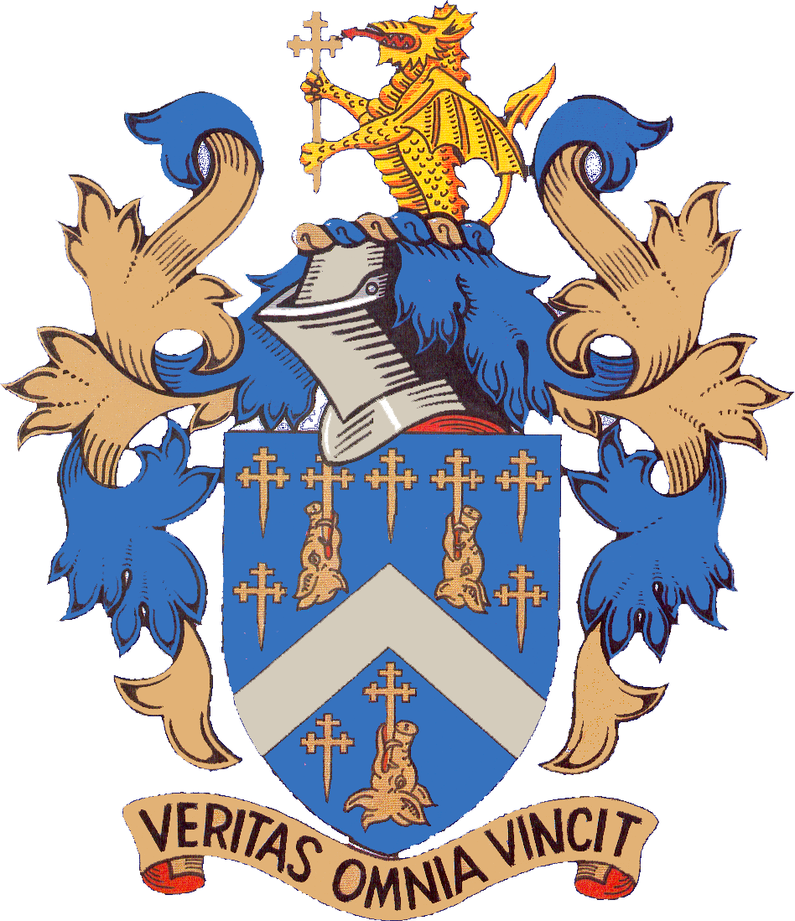

Reading Blue Coat School
Year 12 Art Scholarship Application

Pupil’s name ………………………………………………………………………………..

Date of birth …………………………….

Present school ……………………………………………………………………………..

Year of entry …………………………….

Name of Parent …………………………………………………………………………….

Contact Telephone number ……………………………………………………………….

Contact Email Address …………………………........................................................

Signature of Parent .....................................................................................................

Date ……………........................................

STUDENTS APPLYING FOR 2018-19

Date of Interview: (tbc) Wednesday, 15 November 2017

Appointments are arranged from 4.15pm onwards; you will be informed of the time nearer the date.

What to bring to the interview: Students are asked to bring with them portfolios and any other relevant material including any GCSE artwork, sketchbooks, any visual undertakings of any nature/discipline, etc. They need not bring along any work prior to their Year 9 efforts.

Please complete and return this form to the Admissions Office, Reading Blue Coat School by 10 November 2017.

